CMSC 204

Huffman Lab

1. Create a Huffman Tree and generate the codes for each character of the following input:

create a huffman tree

For consistency:

1. If same frequency – put in priority queue alphabetically; put space before other characters of the same frequency
2. Add subtrees to end of group with same priority
3. Lower number has higher priority (goes to front)

c=1, h=1, m=1, n=1, u=1, f=2, t=2, r=2, ‘ ‘=3, a=3, e=4







Now encode “create a huffman tree”

1001011010111111000110111110110011100000100100001110001101110011010101

1. Based on the following Huffman tree and binary sequence, what is the text

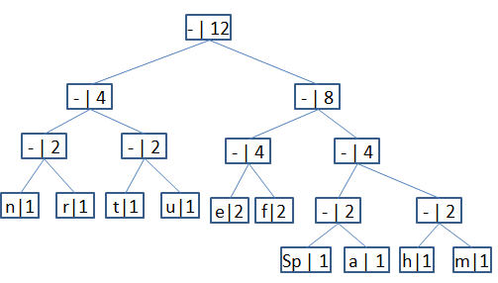

1110 011 101 101 1111 1101 000 1100 010 001 100 100

huffman tree